How to Disable the Minification for specific client libraries (Java Script/CSS) in AEM

Minification helps to reduce the size of the resources (Java Script and CSS) and improves the performance of page loading.

The minfication in AEM can be enabled globally through the following configuration - Adobe Granite HTML Library Manager

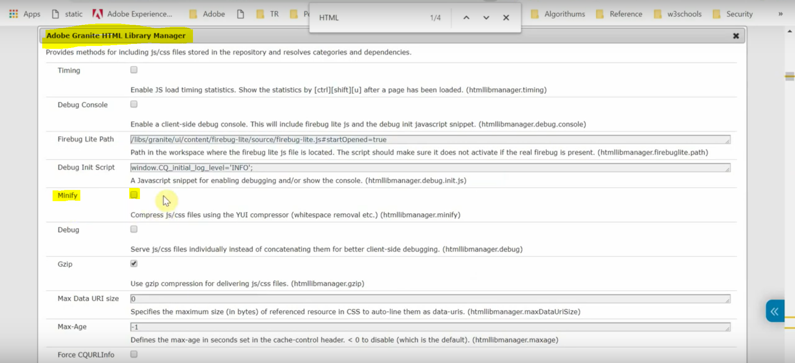

Sometimes we may require to disable the minifcation for specific Java script files may be due to the files are already minified or the issue with minification process.

To disable the minification for specific client library add the below properties to client library node.

Java Script - jsProcessor String[] default:none, min:none

CSS - cssProcessor String[] default:none, min:none

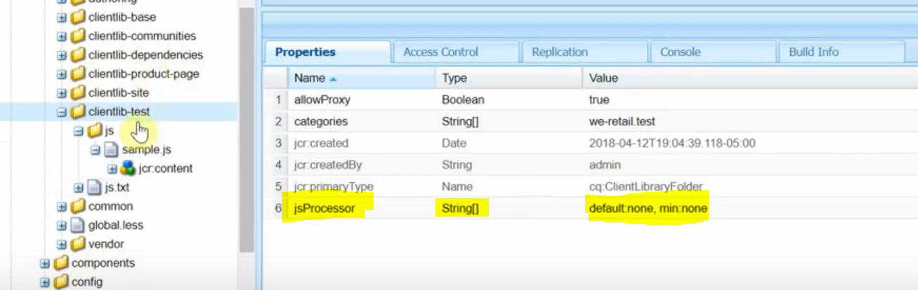

**Verification steps:**

To check whether the resources loaded on the page are minified versions or non-minified versions.

Go to view source of the page and check the resource URL.

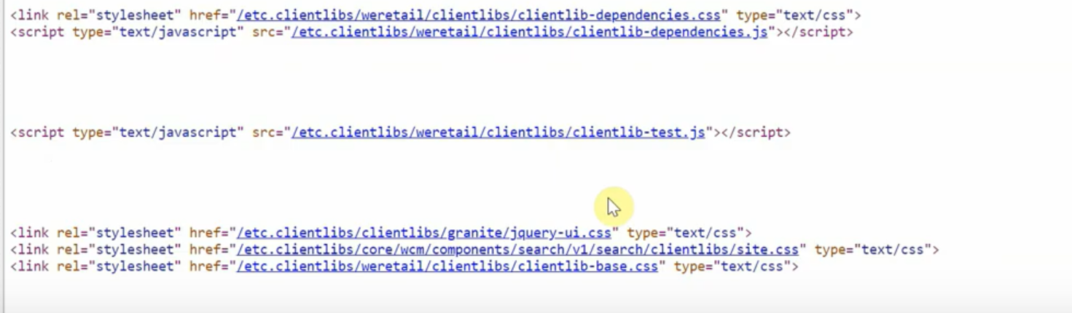

As we can see that there is no “min” selector getting appended in the source URL, the resources are not minified versions.

If the minification is enabled, the resource URLs will have the .min selector. Please refer the below screenshot.

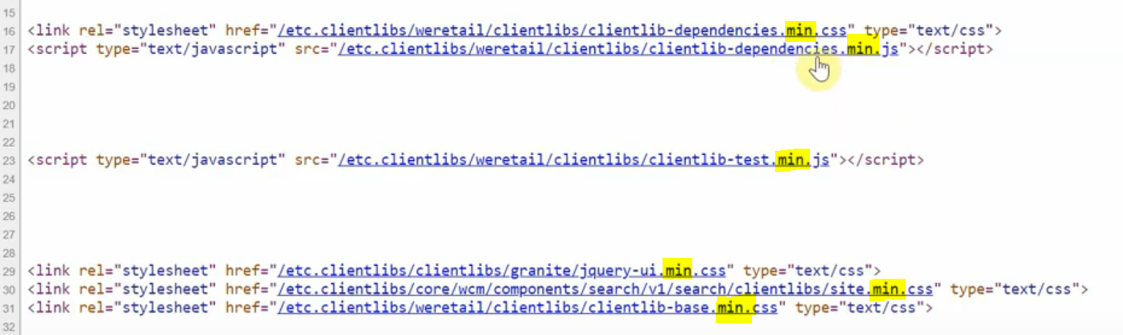

Note: If the resource is already minified and we try to minify it again, an exception would be thrown in the AEM server and the minified resource will not be available to the browser.

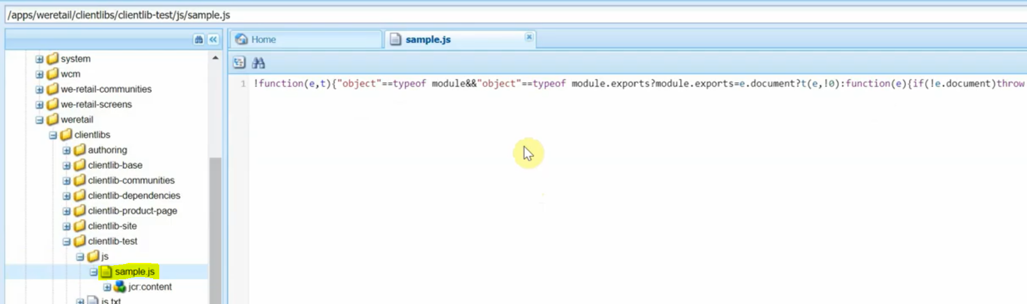

Here the sample.js is already minified.

If we try to access the resource, while the minification is still enabled, this clientlib will not be available to the browser.

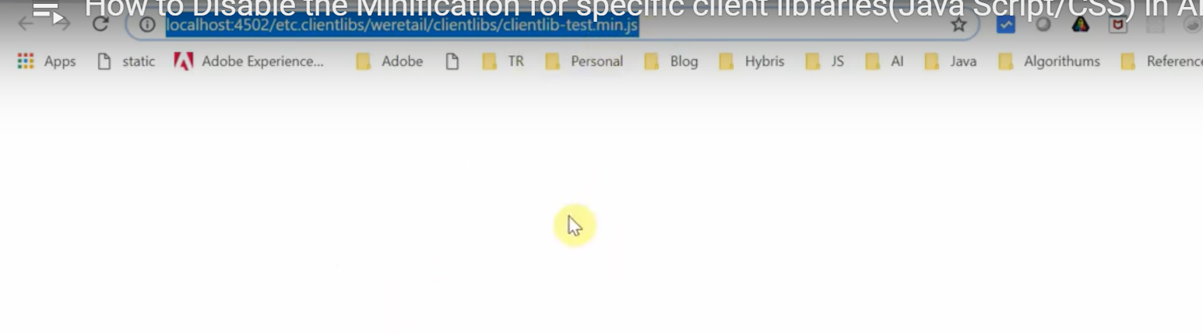

The following error message can be seen after access the clientlibs.

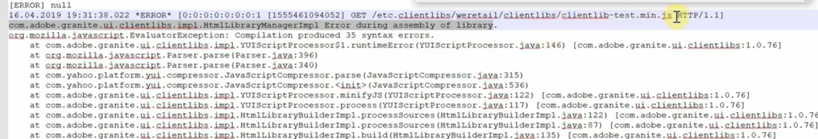

In this case, we can disable the minification to this particular clientlib alone. So that this will be skipped from minifying again.